**TradingDSL final submission information**

**Link to github repository:** [**https://github.com/lukeachristenson/TradingDSL**](https://github.com/lukeachristenson/TradingDSL)

**Relevant commit information:**

1. **We implemented the function version of our DSL for comparison to the macro-based version in a separate branch that we later merged into the main branch. This is the merge commit:**

**Commit ID: 7d1ae04b8de7148c8e977dc4b83ac6f1f420471e**

1. **Some minor Codewalk feedback/fixes (such as making the reference compiler immutable and fixing static check for strategy combination) were implemented in the following 2 commits prior to the commit above:**

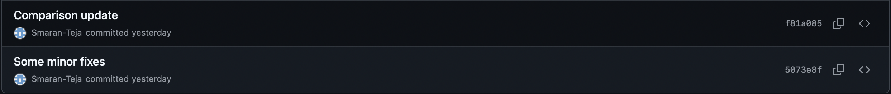

1. **Package documentation was also initially mainly done in a separate branch, and was merged into main. This is the commit**

**Commit ID: f5eb3fe0c67709c40005abd1cdc5ea36dd011826**

**Note: All future commits after the one above (merge #2) were some changes to docs and package setup. We did run into some issues in packaging the DSL due to same naming errors that we were (mostly) able to eventually resolve on our end, however, incase the package docs do not install correctly for some reason, you can access the docs in the scribblings directory with index.html or main.html**